Y7 Drive Regeneration
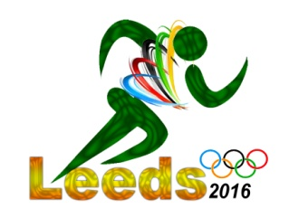
History of the bid / London bid for the 2012 Summer Olympics

From Wikipedia, the free encyclopaedia

London 2012 was the successful bid for the 2012 Summer Games, to be held in London with most events taking place in Stratford, Newham. The British Olympic Association had been working on the bid since 1997. In December 2000 the report was shown to Government ministers.

Following three failed consecutive United Kingdom (UK) bids (Birmingham in 1992 and Manchester in 1996 and 2000), the decision was made to bid with London, given the clear indication that it was the only city in the UK that had a chance of being selected by the International Olympic Committee (IOC) when put up against other world cities in a competitive bidding process.[1] On 6 July 2005 at its 117th Session in Singapore, the IOC awarded the London Bid with the rights to host the Games of the XXX Olympiad. The city beat out the favourite (Paris 2012) on the fourth and final ballot 54 to 50 and will become the first city to host the Games three times.[2]

At the time of the bid, the budget projection was around £2 billion, but more recently, many are saying that the true cost will be around £9 billion[3] and involves a major regeneration of the Stratford area of London, as well as improvements to surrounding services and associated venues.[1] Public transport, an aspect of the proposal which scored poorly for the bid, will see numerous improvements, including the London Underground and the new "Olympic Javelin" service.[4]

The celebrations were partly silenced the day after the announcement of London's win when the city suffered from a terrorist attack. 7 July 2005 London bombings shut down the public transport system and killed 52 people, injuring hundreds more. There was no confirmed link between the IOC decision and the attack.[5]
Following the success of the bid, the London Organising Committee for the Olympic Games and Paralympic Games (LOCOG) was established to oversee the ongoing development of the games. There have been some alterations since the bid was accepted, including the decision by the IOC to eliminate some sporting events[6] and a new layout for the Olympic Zone, both resulting in some relatively minor changes to the 2012 Summer Olympic venues.
Winning the Bid.
London 2012 Olympics: quotes 6/7/05
It's been announced that London will host the Olympic Games in 2012 - the first time the Olympics will be held in Britain since 1948.
Loads of sports stars, politicians and celebs backed the bid, and here's what some had to say about the announcement:
Matthew Pinsent, British Olympic rowing champion
"This is so special... It was four votes between winning and losing -- as close as our race in Athens... The emotion in the last couple of hours has been incredible."

David Beckham, who spoke out to back the bid
"This is going to do so much for our country, not just obviously the East End in London.
For our country it inspires so many children to go out there and, they can go and watch an Olympics, I can go, I can take my children to watch an Olympics where I was, where I was brought up, so it's an amazing feeling.
It's been an honour to be involved. Now we've won it there's a lot to be done."

Prince William, on tour in New Zealand
"I'm looking forward to what I'm sure will be a fantastic Olympic Games."

Paula Radcliffe, world marathon record-holder
"I am really, really pleased. I knew Paris had a great bid but I hoping and finally confident, we would be successful... London will put on a brilliant Games, And yes, if I'm not crocked I hope to be running there."

Jonny Wilkinson, England and Lions rugby star
"London 2012 will be a brilliant sporting event and something for us all to be very proud of."

Gary Lineker, sports presenter and former football star
"The Games will inspire the nation and give us the ability to showcase all that is great about Britain."

Tony Blair, British Prime Minister
"A momentous day for London... I couldn't bear to watch (the final announcement). It is not often in this job that you get to punch the air and do a little jig and embrace the person standing next to you."

Sebastian Coe, who led the London bid
"We are taking home the biggest prize in sport... I always knew this was going to be close... I am absolutely ecstatic ... This is our moment. The spin off for sport in the UK will be huge."

London Mayor Ken Livingstone
"We will promise you a Games you will never forget."

Philippe Baudillon, Chief Executive of the Paris bid
"We are very, very disappointed but it was a very good competition. We thought we could win but obviously we did not ... That's life."

What the Olympic legacy means for East London
The Games will physically transform this part of London putting in place improvements to infra-structure, as well as the Park itself, that will help drive renewal and regeneration in the area. It has replaced over 740 acres of polluted, low-grade industrial land and premises with:
- new sports venues
- a spectacular new waterside park
- a new village of 2800 dwellings
- an improved local rail network
- new state of the art utilities and
- over 100 acres of development land.
These are added to an existing mix which includes:
- Stratford City (Europe's largest shopping centre)
- Stratford International (high speed passenger station)
- Canary Wharf
- The O2 arena and the ExCeL London exhibition centre.
With Crossrail to follow in 2018, the business potential of the area will be transformed. It will place Stratford firmly on London's business map, as a metropolitan focus for sport, shopping, leisure and tourism and for international, creative digital and media business.
The Greater London Authority predict that over 30,000 new homes will be built in the wider Olympic area over the next 20 years, with more than 7,000 in the Olympic Park site itself. New and existing residents will have access to:
- one of the most spectacular urban parks in the world
- a new Polyclinic providing a wide range of health care services in one place
- Chobham Academy - a new all age academy and the new Birkbeck/University of East London higher education college
- improved rail access to all parts of London and beyond
- some of the best shopping and leisure facilities in London
- new sports facilities.
Other important local town centres and open spaces, including Victoria Park, Hackney Marshes and Cutty Sark Gardens, are being regenerated and the water quality of the Lower Lee improved. The development of the Olympic and Paralympic Games has been used to provide jobs and training for local people, and programmes such as the Local Employment Skills and Training programme (LEST) are being rolled out more widely across east London. In addition, local boroughs, the Mayor, and other agencies, are working together more closely, with Government's support, on programmes to address the deep seated social disadvantage experienced by many of the local population. Educational attainment, skills, crime levels, health disparities and life expectancy are all being targeted.
What the Department is doing
The Olympic Park Legacy Company has the specific remit to take on the long-term and complex task of planning, delivering and maintaining the Olympic Park after the London 2012 Olympic and Paralympic Games. Their task is to transform the Park into world-class, sustainable, thriving neighborhoods, which integrate well with their surroundings. A key Government priority is to bring about a fundamental change in the relationship between citizens and the state by shifting power away from the centre. The responsibility to direct and manage the Park legacy is being decentralised to the Mayor of London. Legislation in the Localism Bill will enable the Mayor to set up a Mayoral Development Corporation (MDC) to take over the role of the Olympic Park Legacy Company. It will ensure that the regeneration of the Olympic Park and surrounding area - which is a top strategic priority for London, as set out in the Mayor's London Plan - is undertaken by an authority directly responsible to London's elected Mayor, rather than central Government.
The Department also has a key role in ensuring that its delivery bodies are ready to provide the necessary services during Games-time. In particular the Chief Fire and Rescue Advisor and his team are working with local fire brigades to make sure they are fully prepared and ready to play their vital role during the Olympic and Paralympic Games.
Local authorities provide many of the services essential to our day to day lives. They also play an important hosting role in the Olympic and Paralympic Games whether they are providing venues for events such as sailing in Weymouth, pre-Games training venues or the Olympic torch relay.

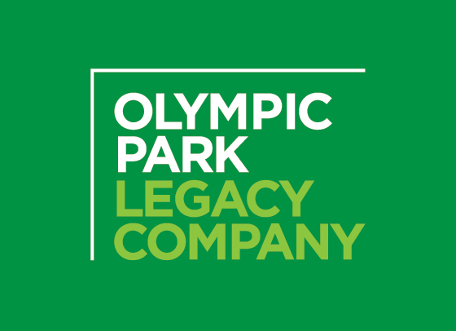

Y7 Drive Task 3 – summarise the above pages to show understanding of each topic.

History of the bid / London bid for the 2012 Summer Olympics

Winning the Bid.

What the Olympic legacy means for East London

What the Department is doing

